How to Execute BA-EE Automation Scripts:

Pre-Requisites:
- RenewalCenter should be enabled to run RC related below Scripts.
- Speridian_RC_EmpFlow
- Speridian_RC_Admin_BA_Flow
- IHA_RC_EmpFlow
- IHA_RC_Admin_BA_Flow
- FBMC_RC_EmpFlow
- FBMC_RC_Admin_BA_Flow

Maintenance Activity:
Note: If required please delete the data before Run the Suite based on your need base.
- Delete the Report Folder Data
- Delete the Screenshot Folder Data
- Delete the Download Folder Data

Steps:
- Install the Eclipse- Follow below setup doc.

- Load the Project in Eclipse.
- Expand Project Folder.
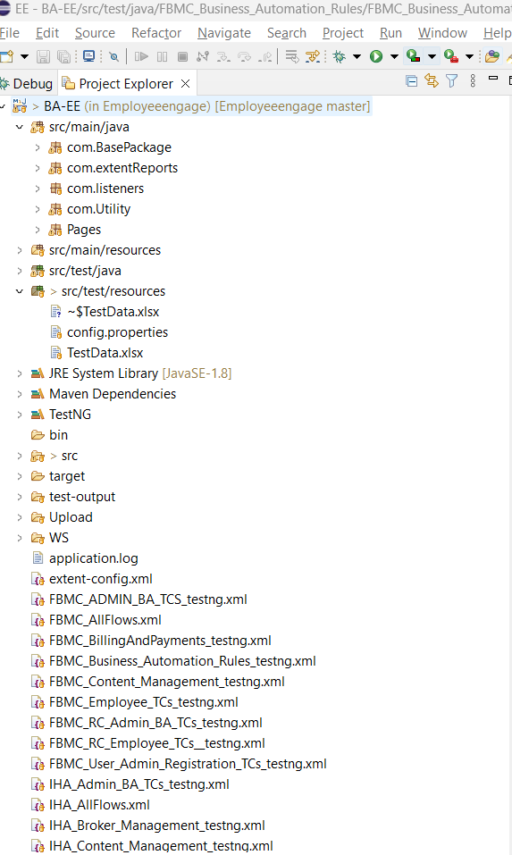

URL and Usernames Update:
To update URL, Usernames based on the Role and Tenant details, Expand Src/main/resources folder and Open config. properties file and update accordingly.
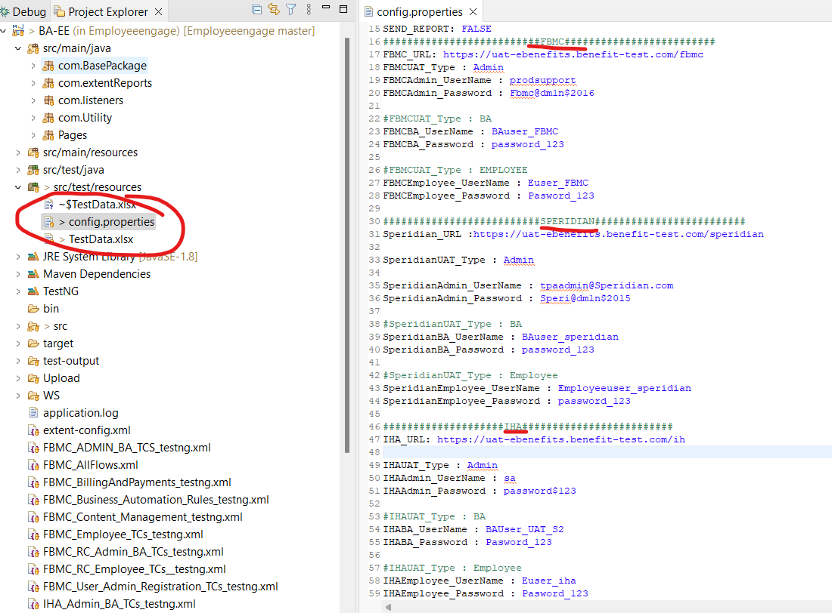

Test Data Updates:
- For Eg:- To run FBMC_Business_Automation_Rules, Expand Src/main/resources folder and Open TestData.xlsx using below steps:
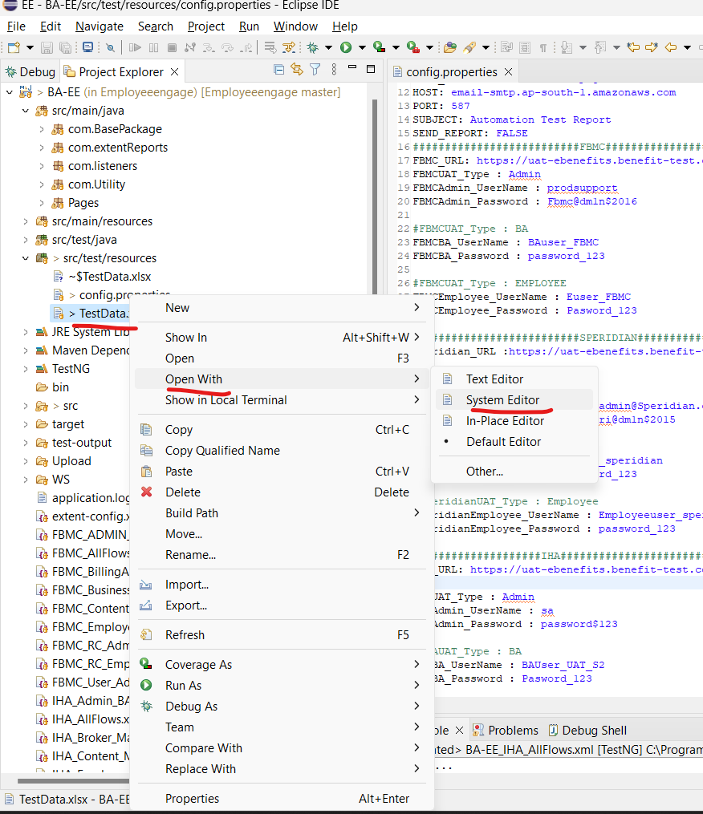

Moreover, Update the Test Data sheets of FBMC_Business_Automation_Rules for FBMC_Business_Automation_Rules TestCases:

Note: Check, all the columns and update required ones like EffectiveDate etc….

- Make sure Run column is updated with “Yes” for all Test scenarios in the Test Data Sheets.
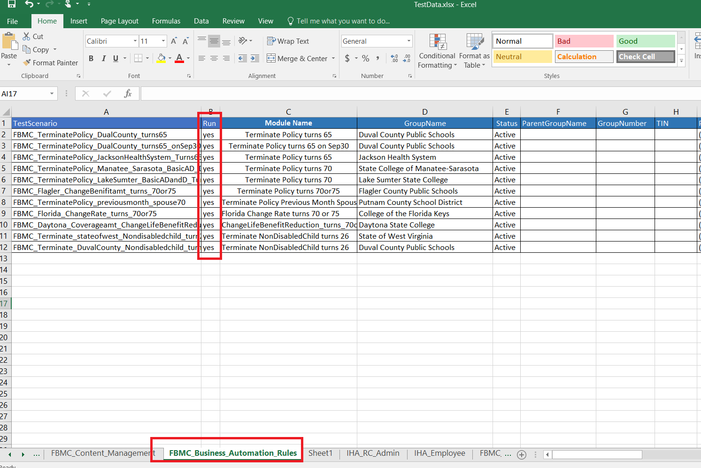

How to run Test Suite(testng) xml:
There are 3 testng xmls and 1 xml for each tenant ::
- FBMC_AllFlows.xml
- Speridian_AllFlows.xml
- IHA_AllFlows.xml

In eclipse Right click on the “FBMC_AllFlows.xml”Run As TestNG Suite
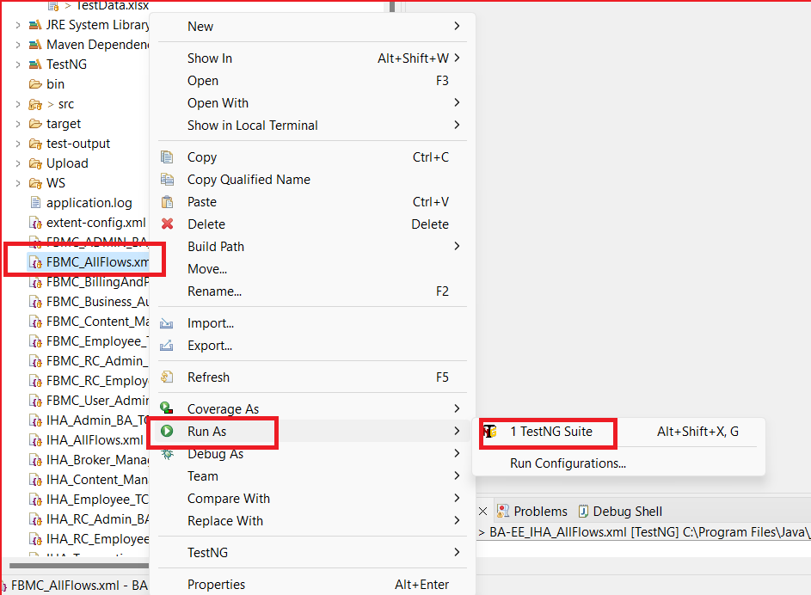

Note: Same thing can do to run suite for other Tenants as well.
How to get Report to Email Ids or DLs::
- Open config.properties file and update “TO”(Recipient List) and SEND_REPORT to “TRUE” as below:
Note:
By default, SEND_REPORT value is set to FALSE.
You can Update SUBJECT, FROM Name accordingly.

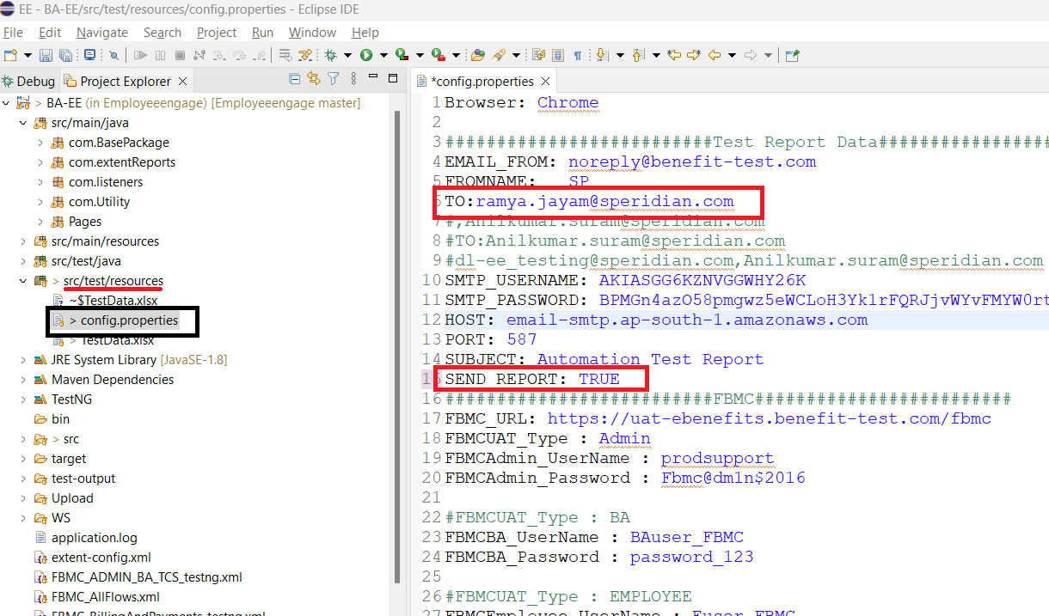
You receive Test report once after test execution is completed.
You can Find in Inbox or Junk Folder.
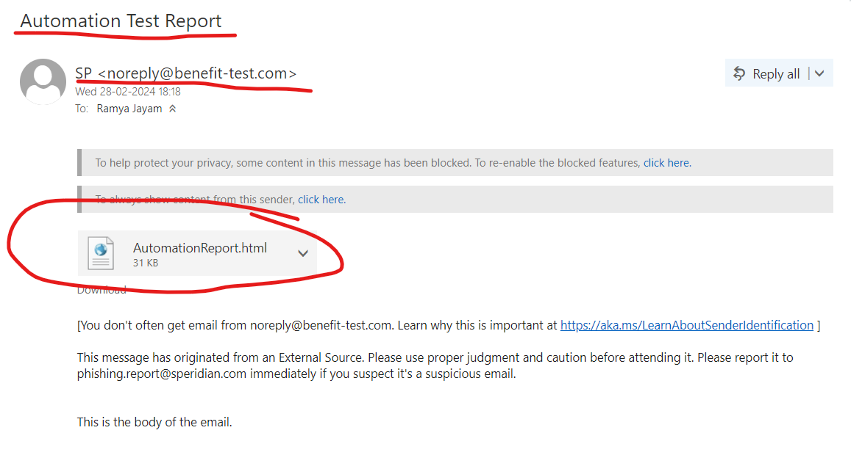
How and Where to See Reports, in case of not getting an Email:
- Expand TestReport folder as below:

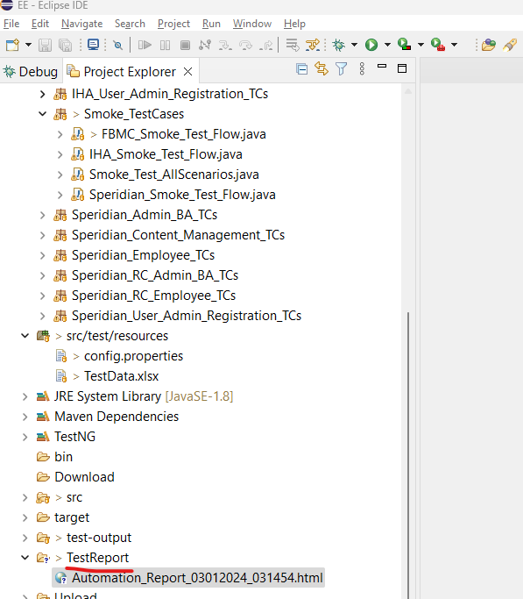
- Report is generated with current date and Timestamp.
- Double click on the Report and it opens in browser as below and can see Total Number of Test Cases Passed and Failed:
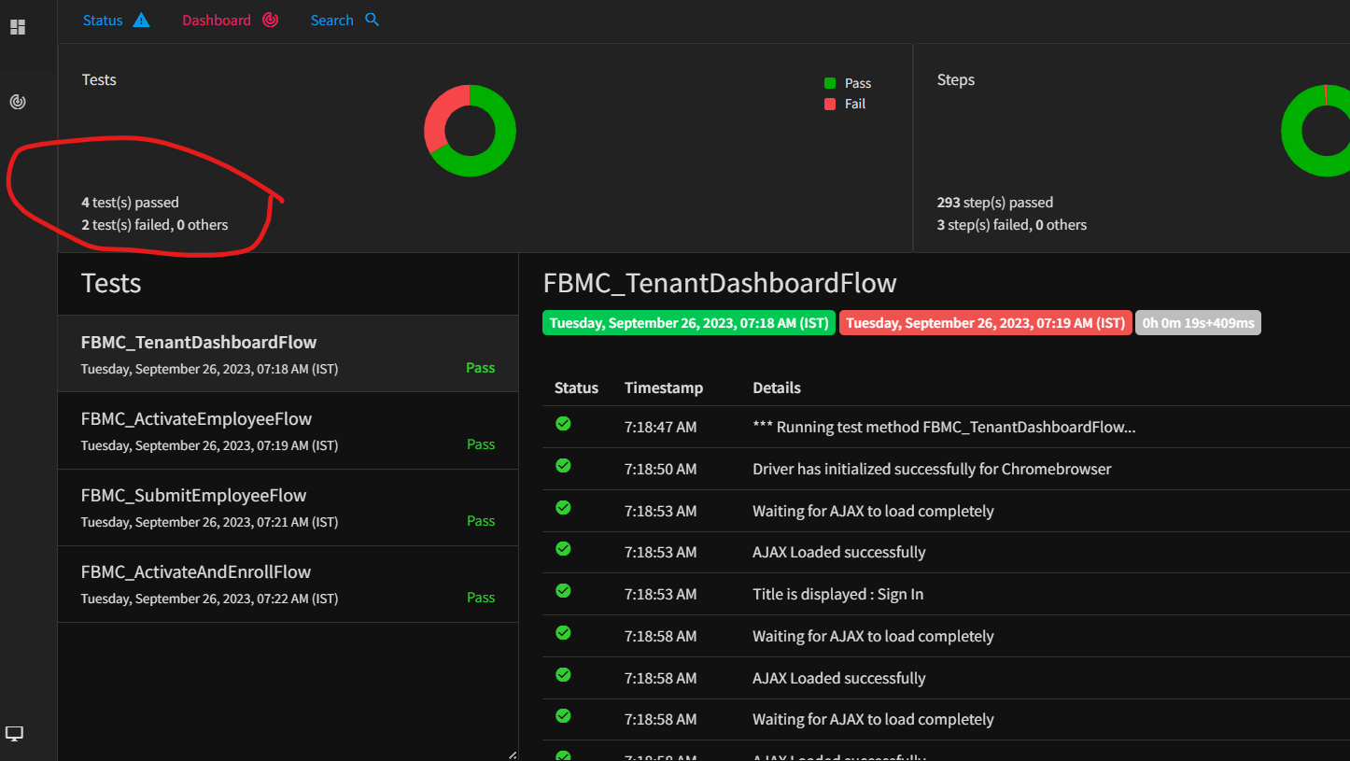
- To see only Passed TCS, click on the Status and select Pass, it shows only Passed Tcs:
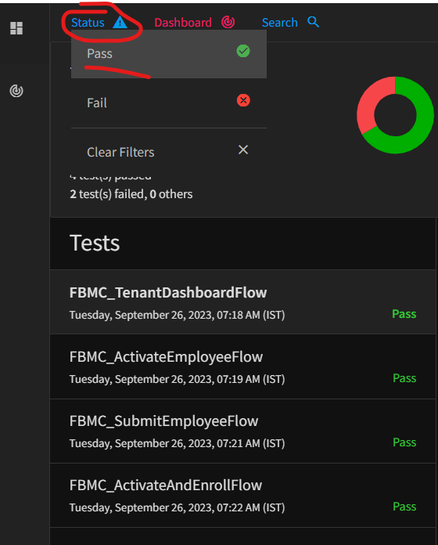

- To see only Failed TCS, click on the Status and select Fail, it shows only Failed Test cases:
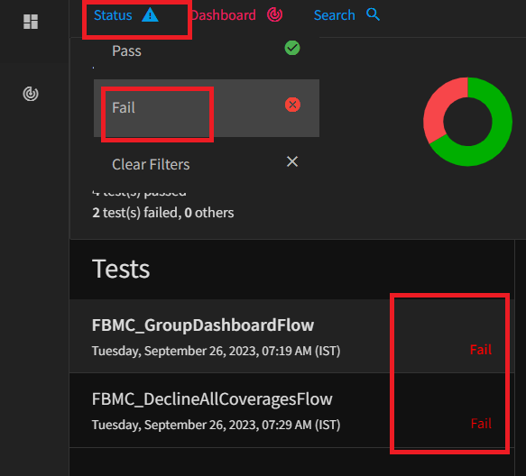

- To check Execution Time:

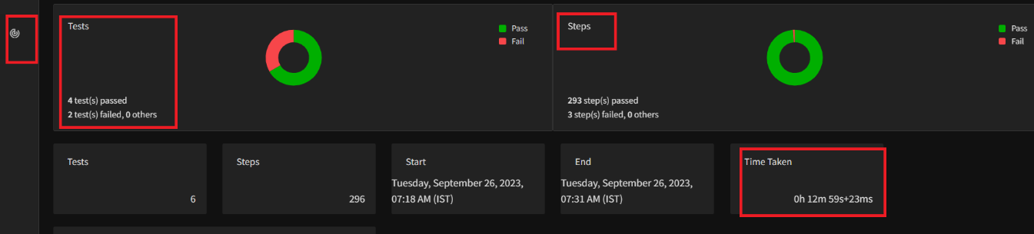
Where to See Downloaded Files/Reports:
- Expand Download Folder as below:

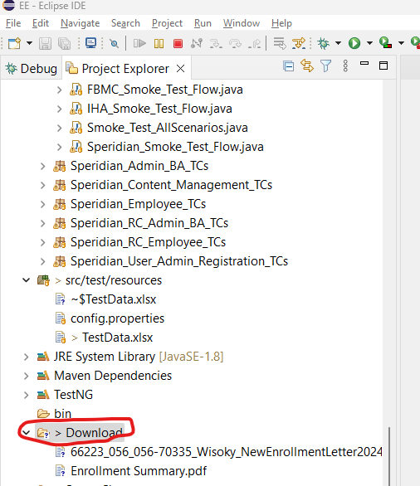

Where to See Screenshots:
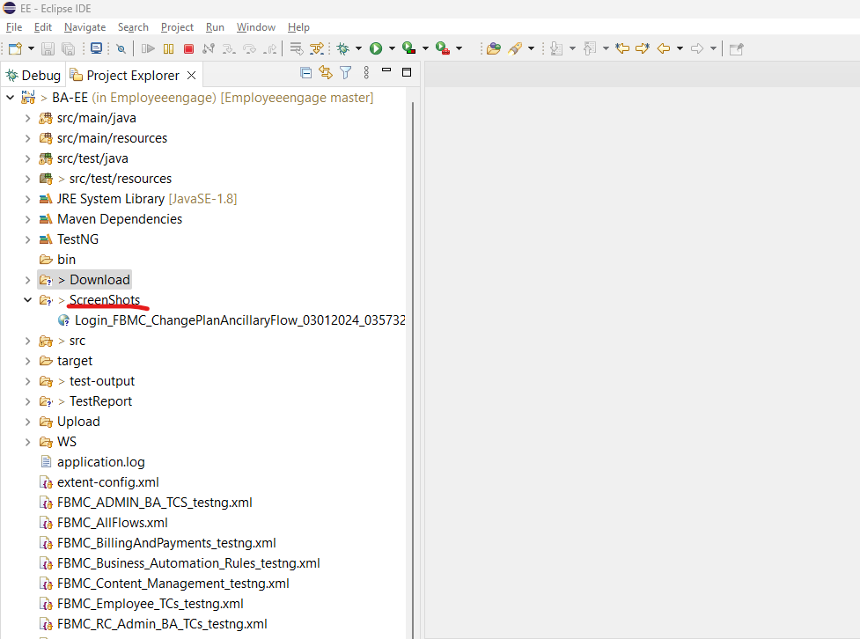

Navigation to Test Reports local folder:
In Eclipse Right click on the “TestReport”Propertiesclick on the Icon(shown in the 2nd screenshot)

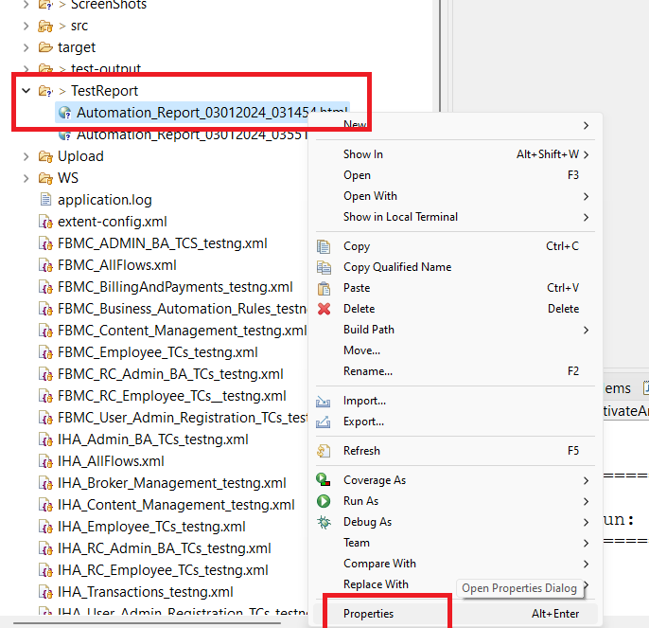
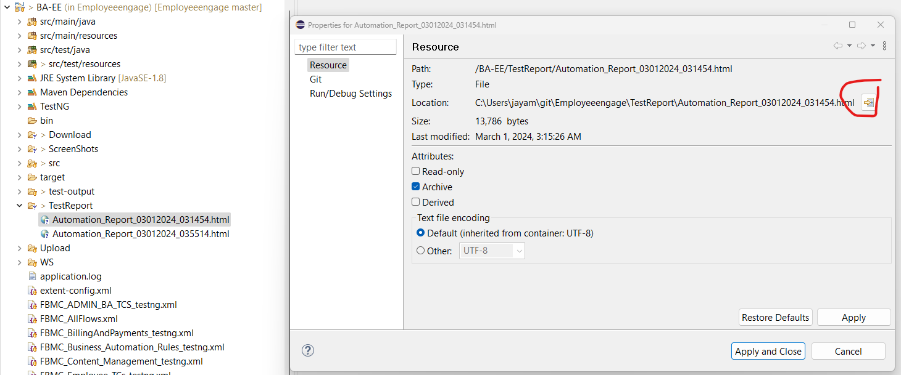

It navigates to the Local folder where the Reports are stored:
